**Assignment 25.2**

**Loading Olympic Data**

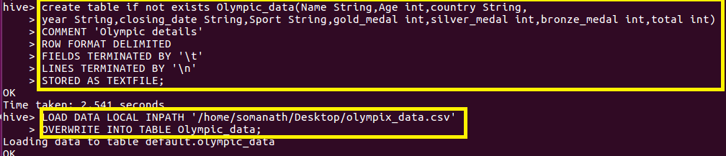

**Write a Hive Program to find the total number of medals each country won**

**Since we want to find the medals won by country, sum the total medals and gave an alias name as total_medals and group by country.**

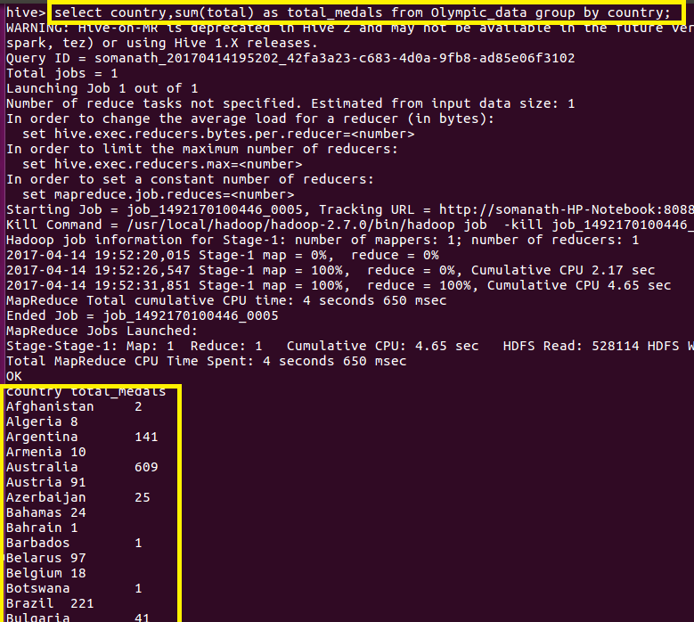

**Output**

**FULL OUTPUT AS COPIED FROM HIVE**

**Country total_medals**

|  |  |  |  |  |  |
| --- | --- | --- | --- | --- | --- |
|  |  |  |  |  |  |
|  |  |  |  |  |  | **Afghanistan 2** |
|  |  |  |  |  |  | **Algeria 8** |
|  |  |  |  |  |  | **Argentina 141** |
|  |  |  |  |  |  | **Armenia 10** |
|  |  |  |  |  |  | **Australia 609** |
|  |  |  |  |  |  | **Austria 91** |
|  |  |  |  |  |  | **Azerbaijan 25** |
|  |  |  |  |  |  | **Bahamas 24** |
|  |  |  |  |  |  | **Bahrain 1** |
|  |  |  |  |  |  | **Barbados 1** |
|  |  |  |  |  |  | **Belarus 97** |
|  |  |  |  |  |  | **Belgium 18** |
|  |  |  |  |  |  | **Botswana 1** |
|  |  |  |  |  |  | **Brazil 221** |
|  |  |  |  |  |  | **Bulgaria 41** |
|  |  |  |  |  |  | **Cameroon 20** |
|  |  |  |  |  |  | **Canada 370** |
|  |  |  |  |  |  | **Chile 22** |
|  |  |  |  |  |  | **China 530** |
|  |  |  |  |  |  | **Chinese Taipei 20** |
|  |  |  |  |  |  | **Colombia 13** |
|  |  |  |  |  |  | **Costa Rica 2** |
|  |  |  |  |  |  | **Croatia 81** |
|  |  |  |  |  |  | **Cuba 188** |
|  |  |  |  |  |  | **Cyprus 1** |
|  |  |  |  |  |  | **Czech Republic 81** |
|  |  |  |  |  |  | **Denmark 89** |
|  |  |  |  |  |  | **Dominican Republic 5** |
|  |  |  |  |  |  | **Ecuador 1** |
|  |  |  |  |  |  | **Egypt 8** |
|  |  |  |  |  |  | **Eritrea 1** |
|  |  |  |  |  |  | **Estonia 18** |
|  |  |  |  |  |  | **Ethiopia 29** |
|  |  |  |  |  |  | **Finland 118** |
|  |  |  |  |  |  | **France 318** |
|  |  |  |  |  |  | **Gabon 1** |
|  |  |  |  |  |  | **Georgia 23** |
|  |  |  |  |  |  | **Germany 629** |
|  |  |  |  |  |  | **Great Britain 322** |
|  |  |  |  |  |  | **Greece 59** |
|  |  |  |  |  |  | **Grenada 1** |
|  |  |  |  |  |  | **Guatemala 1** |
|  |  |  |  |  |  | **Hong Kong 3** |
|  |  |  |  |  |  | **Hungary 145** |
|  |  |  |  |  |  | **Iceland 15** |
|  |  |  |  |  |  | **India 11** |
|  |  |  |  |  |  | **Indonesia 22** |
|  |  |  |  |  |  | **Iran 24** |
|  |  |  |  |  |  | **Ireland 9** |
|  |  |  |  |  |  | **Israel 4** |
|  |  |  |  |  |  | **Italy 331** |
|  |  |  |  |  |  | **Jamaica 80** |
|  |  |  |  |  |  | **Japan 282** |
|  |  |  |  |  |  | **Kazakhstan 42** |
|  |  |  |  |  |  | **Kenya 39** |
|  |  |  |  |  |  | **Kuwait 2** |
|  |  |  |  |  |  | **Kyrgyzstan 3** |
|  |  |  |  |  |  | **Latvia 17** |
|  |  |  |  |  |  | **Lithuania 30** |
|  |  |  |  |  |  | **Macedonia 1** |
|  |  |  |  |  |  | **Malaysia 3** |
|  |  |  |  |  |  | **Mauritius 1** |
|  |  |  |  |  |  | **Mexico 38** |
|  |  |  |  |  |  | **Moldova 5** |
|  |  |  |  |  |  | **Mongolia 10** |
|  |  |  |  |  |  | **Montenegro 14** |
|  |  |  |  |  |  | **Morocco 11** |
|  |  |  |  |  |  | **Mozambique 1** |
|  |  |  |  |  |  | **Netherlands 318** |
|  |  |  |  |  |  | **New Zealand 52** |
|  |  |  |  |  |  | **Nigeria 39** |
|  |  |  |  |  |  | **North Korea 21** |
|  |  |  |  |  |  | **Norway 192** |
|  |  |  |  |  |  | **Panama 1** |
|  |  |  |  |  |  | **Paraguay 17** |
|  |  |  |  |  |  | **Poland 80** |
|  |  |  |  |  |  | **Portugal 9** |
|  |  |  |  |  |  | **Puerto Rico 2** |
|  |  |  |  |  |  | **Qatar 3** |
|  |  |  |  |  |  | **Romania 123** |
|  |  |  |  |  |  | **Russia 768** |
|  |  |  |  |  |  | **Saudi Arabia 6** |
|  |  |  |  |  |  | **Serbia 31** |
|  |  |  |  |  |  | **Serbia and Montenegro 38** |
|  |  |  |  |  |  | **Singapore 7** |
|  |  |  |  |  |  | **Slovakia 35** |
|  |  |  |  |  |  | **Slovenia 25** |
|  |  |  |  |  |  | **South Africa 25** |
|  |  |  |  |  |  | **South Korea 308** |
|  |  |  |  |  |  | **Spain 205** |
|  |  |  |  |  |  | **Sri Lanka 1** |
|  |  |  |  |  |  | **Sudan 1** |
|  |  |  |  |  |  | **Sweden 181** |
|  |  |  |  |  |  | **Switzerland 93** |
|  |  |  |  |  |  | **Syria 1** |
|  |  |  |  |  |  | **Tajikistan 3** |
|  |  |  |  |  |  | **Thailand 18** |
|  |  |  |  |  |  | **Togo 1** |
|  |  |  |  |  |  | **Trinidad and Tobago 19** |
|  |  |  |  |  |  | **Tunisia 4** |
|  |  |  |  |  |  | **Turkey 28** |
|  |  |  |  |  |  | **Uganda 1** |
|  |  |  |  |  |  | **Ukraine 143** |
|  |  |  |  |  |  | **United Arab Emirates 1** |
|  |  |  |  |  |  | **United States 1312** |
|  |  |  |  |  |  | **Uruguay 1** |
|  |  |  |  |  |  | **Uzbekistan 19** |
|  |  |  |  |  |  | **Venezuela 4** |
|  |  |  |  |  |  | **Vietnam 2** |
|  |  |  |  |  |  | **Zimbabwe 7** |
|  |  |  |  |  |  | **Time taken: 31.882 seconds, Fetched: 110 row(s)** |
|  |  |  |  |  |  | **hive>** |
|  |  |  |  |  |  |  |
|  |  |  |  |  |  |  |

**Write a Hive program to find the number of gold medals each country won. Since we want to find the gold medals won by country, sum the gold medals and gave alias name as total_gold_medals and group by country.**

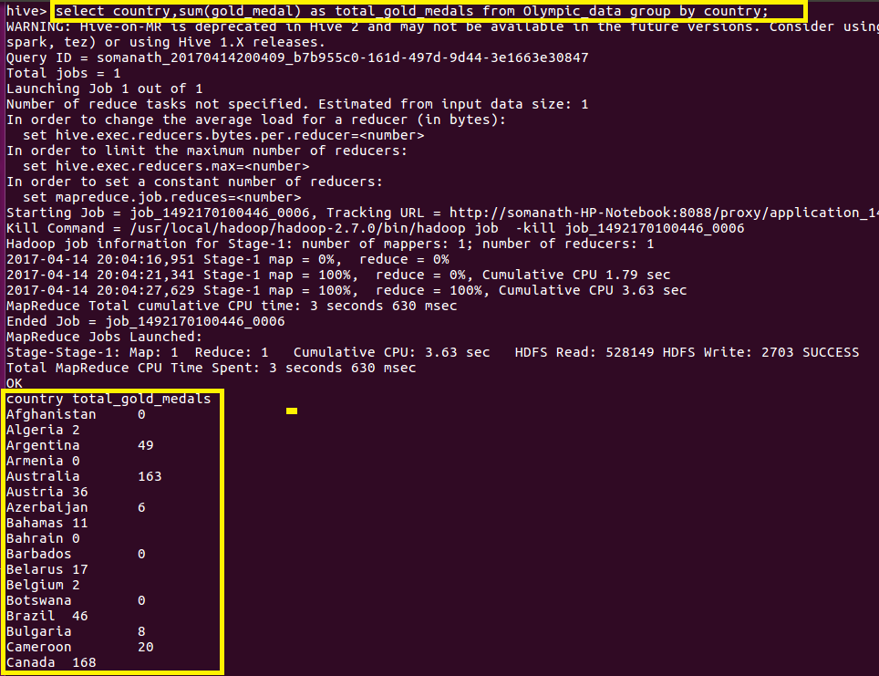

**Output**

**Country total_gold_medals**

**Afghanistan 0**

**Algeria 2**

**Argentina 49**

**Armenia 0**

**Australia 163**

**Austria 36**

**Azerbaijan 6**

**Bahamas 11**

**Bahrain 0**

**Barbados 0**

**Belarus 17**

**Belgium 2**

**Botswana 0**

**Brazil 46**

**Bulgaria 8**

**Cameroon 20**

**Canada 168**

**Chile 3**

**China 234**

**Chinese Taipei 2**

**Colombia 2**

**Costa Rica 0**

**Croatia 35**

**Cuba 57**

**Cyprus 0**

**Czech Republic 14**

**Denmark 46**

**Dominican Republic 3**

**Ecuador 0**

**Egypt 1**

**Eritrea 0**

**Estonia 6**

**Ethiopia 13**

**Finland 11**

**France 108**

**Gabon 0**

**Georgia 6**

**Germany 223**

**Great Britain 124**

**Greece 12**

**Grenada 1**

**Guatemala 0**

**Hong Kong 0**

**Hungary 77**

**Iceland 0**

**India 1**

**Indonesia 5**

**Iran 10**

**Ireland 1**

**Israel 1**

**Italy 86**

**Jamaica 24**

**Japan 57**

**Kazakhstan 13**

**Kenya 11**

**Kuwait 0**

**Kyrgyzstan 0**

**Latvia 3**

**Lithuania 5**

**Macedonia 0**

**Malaysia 0**

**Mauritius 0**

**Mexico 19**

**Moldova 0**

**Mongolia 2**

**Montenegro 0**

**Morocco 2**

**Mozambique 1**

**Netherlands 101**

**New Zealand 18**

**Nigeria 6**

**North Korea 6**

**Norway 97**

**Panama 1**

**Paraguay 0**

**Poland 20**

**Portugal 1**

**Puerto Rico 0**

**Qatar 0**

**Romania 57**

**Russia 234**

**Saudi Arabia 0**

**Serbia 1**

**Serbia and Montenegro 11**

**Singapore 0**

**Slovakia 10**

**Slovenia 5**

**South Africa 10**

**South Korea 110**

**Spain 19**

**Sri Lanka 0**

**Sudan 0**

**Sweden 57**

**Switzerland 21**

**Syria 0**

**Tajikistan 0**

**Thailand 6**

**Togo 0**

**Trinidad and Tobago 1**

**Tunisia 2**

**Turkey 9**

**Uganda 1**

**Ukraine 31**

**United Arab Emirates 1**

**United States 552**

**Uruguay 0**

**Uzbekistan 5**

**Venezuela 1**

**Vietnam 0**

**Zimbabwe 2**

**Time taken: 18.848 seconds, Fetched: 110 row(s)**